PH126 Logic I Lecture 14
Lecturer: s.butterfill@warwick.ac.uk

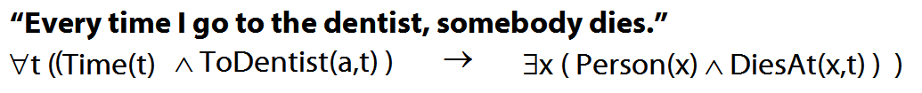

Truth-functional completeness (LPL §7.4)
Preliminary: How many truth-functions can be constructed using 2 sentence letters?

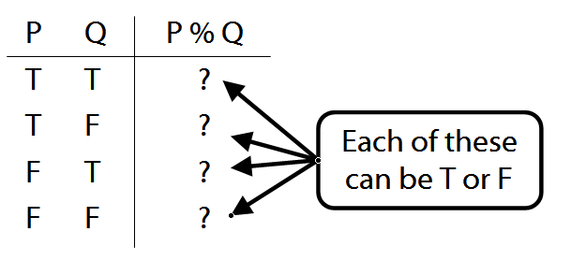

Truth-functional completeness: For any truth function, we can easily find a logically equivalent one using only ¬, ∨, ∧

Better: ‘A set of truth-functors is said to be expressively adequate (or sometimes functionally complete) iff, for every truth-function whatever, there is a formula containing only those truth-functors which express that truth-function, i.e. which has as its truth-table the truth-table specifying that function.’ (Bostock, Intermediate L’gic p. 45)
Illustration of how the proof that {¬, ∧, ∨ is truth-functionally complete}:
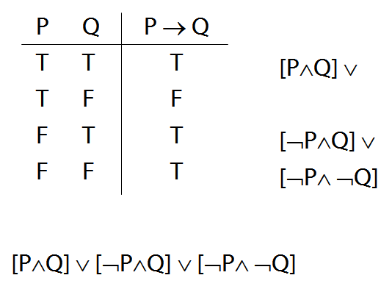

Exercise assuming {¬,∨,∧} is truth-functionally complete, show that {¬,∨} is?
Quantifier equivalences
P→Q ╡╞ ¬Q→¬P
∀x ( Square(x) → Broken(x) )
╡╞ ∀x (¬Broken(x) → ¬Square(x) )

P→Q ╡╞ ¬P∨Q
∀x ( Square(x) → Broken(x) )
╡╞ ∀x (¬Square(x) ∨ Broken(x) )

¬P∨Q ╡╞ ¬(P∧ ¬Q)
∃x ¬F(x) ╡╞ ¬∀x F(x)
∀x (¬Square(x) ∨ Broken(x) )
╡╞ ∃¬x ( Square(x) ∧ ¬Broken(x) )

∃x ¬Created(x) ╡╞ ¬∀x Created(x)
Hybrid example
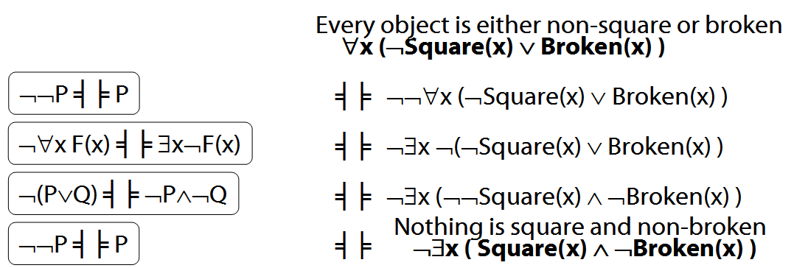

Variables
Names : a, b, c, …
Variables : x, y, z, w, …
Variables are for saying several things about one thing even without specifying which thing
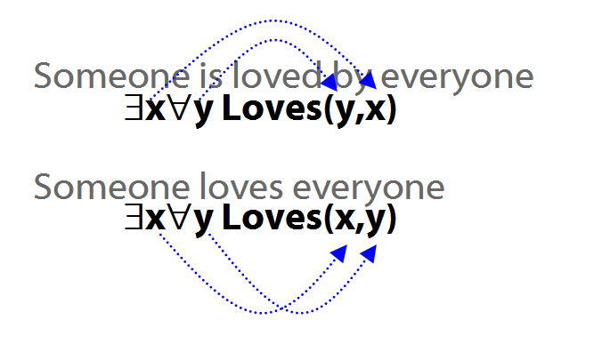
Optional extra proofs
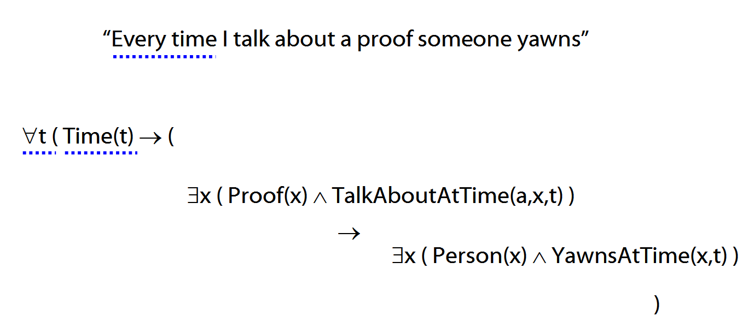
Some not all are valid. Prove the valid ones, give counterexamples for the non-valid.

1. ∃x ∀y R(x,y) ├ ∀y ∃x R(x,y)
2. ∀x ¬F(x) ├ ¬∃x F(x)
3. ¬∃x F(x) ├ ∀x ¬F(x)
4. ∀x F(x) | ∀x G(x) ├ ∀x (Fx ∨ Gx)
5. ∀x (Fx ∨ Gx) ├ ∀x F(x) | ∀x G(x)
6. ∀x F(x) ∨ ∃y F(y) ├ ∃y ∀x ( F(x) ∨ F(y) )
7. ∀x (F(x) ↔ x=a), ∀x (G(x) ↔ x=b) ├
a=b ↔ G(a)
8. ∃y ∀x (F(x) ↔ x=y) ├ (F(a) ∧ F(b) → a=b)

